8th International Volcano Geology Workshop

Reconstruction of the temporal evolution of volcanic activities from geological evidence 7th-13th March 2027. Kirishima and Aira-Sakurajima volcanoes, Japan

SECOND CIRCULAR

Version 2.2 with Registration Link
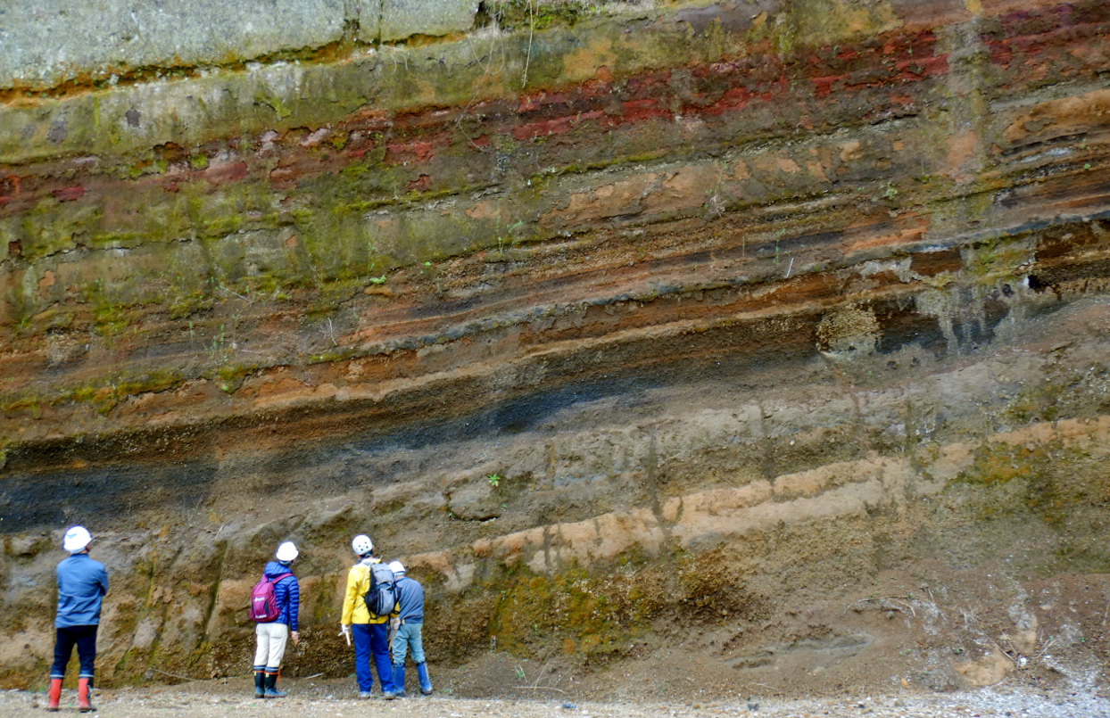
October 1, 2026

We are pleased to announce the details regarding the 8th IAVCEI Volcano Geology Workshop, scheduled from 7 to 13 March 2027 in the Kirishima Volcano and Sakurajima-Aira Volcano areas. We look forward to your participation.
This workshop is organized as an activity of the IAVCEI commission Volcano Geology and receives financial support from IAVCEI. Anyone can participate but those that intend to apply for reimbursement of the registration fee must be IAVCEI members. If you are not currently a member, we encourage you to join IAVCEI.
IAVCEI membership site: https://www.iavceivolcano.org/membership/
Membership registration form: https://iavcei.gmem.eu/form/1-members-registration-form-main

● Call for Participants
Registration opens: October 1, 2026 (First-come, first-served basis).
Registration is confirmed upon completion of both registration and payment of the registration fee. Registration will close once capacity (40) is reached (or end of October).
Registration and payment must be completed via the website. Payment of the participation fee is accepted via credit card only; bank transfers and other methods are not accepted.

Link to the registration website
https://va.apollon.nta.co.jp/IVACEI2027/
The travel agency Nippon Travel Agency Co., Ltd. (Kyushu Corporate Sales Department) conducts the payment site and the handling of travel arrangements for the workshop on the outsourcing contract with the LOC.

● Participation Fee

Fee: 180,000 JPY (approx.. 1000€ or 1.100 US-$)
This includes:
* Accommodation from March 7 to March 13 (6 nights) in twin room base
* Icebreaker on the evening of March 7 and Farewell events on March 12
* Breakfast, lunch, and dinner from the morning of March 8 to midday on March 13
* Transfer cost (Tour bus) from March 9 to March 13
* Conference materials
* Credit card processing fees

With support from IAVCEI, we plan to provide partial financial assistance to cover registration fees for selected IAVCEI members. Priority will be given to early-career researchers (ECRs) and participants from low-income countries. Details will be announced to the participants after the registration is closed. Requests for assistance will be accepted at the time of registration.

● Poster Session
Participants will have the opportunity to present their research during the poster session on March 8. Please register the tentative presentation title and presenter(s) at the time of registration (details can be added or updated later).
Poster presentation: Approximately one A0-sized poster (landscape orientation). Displays such as geological maps are also possible (please consult the LOC regarding extra space prior to the workshop).
If you wish to give a poster presentation, please prepare and submit an abstract of up to 4 pages using the attached MS-Word file. The deadline for abstract submission is the end of December. Instructions regarding the submission process will be provided separately.

Fundamental Information (basically unchanged from the 1st Circular)

The 1st Circular

● Meeting and drop-off locations
* Meeting Date, Time, and Location
March 7. 18:00: Lobby of Main Hotel (Miyakonojo City, Miyazaki Prefecture)
Address: 8-9 Kamimachi, Miyakonojo, Miyazaki
Global Position: 31.72471N, 131.06336E
Google Map Location: https://maps.app.goo.gl/piaxxrrg5j672T5dA

* Drop-off: Date, Expected Time, and Location
March 13, approx. 16:00: Kagoshima-Chuo Station West Exit (Kagoshima City, Kagoshima Prefecture)
Global Position: 31.58456N, 130.54105E
Google Map Location: https://maps.app.goo.gl/2U54bGAuwNW8kTLe6

● Accommodations
* Main Hotel (Miyakonojo City, Miyazaki Prefecture): March 7 - 10
* Satsukien, (Kanoya City, Kagoshima Prefecture): March 10 - 13
(mixture of single – twin rooms)

Planning Schedule
March 7: Arrival, Registration, Icebreaker.
March 8: Keynote talk, Scientific Discussions, Poster session.
March 9: Field trip (Kirishima volcano)
March 10: Field trip (Kirishima and Aira caldera)
March 11: Field trip (Sakurajima tephra deposits)
March 12: Field trip (Aira and Ata calderas), Closing scientific meeting, Farewell Dinner.
March 13: Half day field trip (Sakurajima), Drop-off at Kagoshima-Chuo Station.

● Contact
Any contact about the 8th Volcano Geology Workshop is welcome to the following contact e-mail address.
Email: iavceivolgeo2027@googlegroups.com

LOC Leader:
Nobuo Geshi (Kyushu University), IAVCEI Scientific Councillor
Department of Earth and Planetary Science, Kyushu University (Fukuoka, Japan)
Co-Leaders (in alphabetical order)
Tatsuya Konoo
Geological Survey Japan, AIST (Tsukuba, Japan)
Ayumu Nishihara
Tokoha University (Shizuoka, Japan)
Taketo Shimano
Kagoshima University (Kagoshima, Japan)
Yasuhisa Tajima
Nippon Koei co. ltd. (Tsukuba, Japan)

